**CS555 Project Report**

**Xiruo Li(xiruoli2)**

**Part 1**

(1) solution fields (u, v and p) for the most fined mesh.

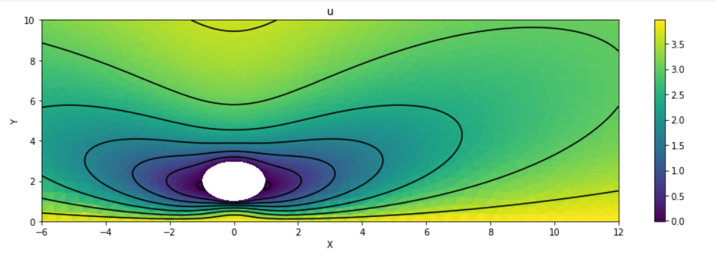

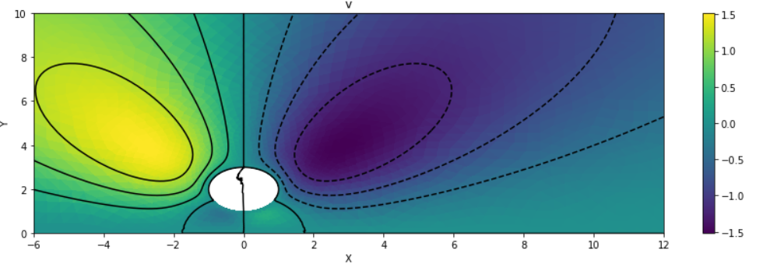

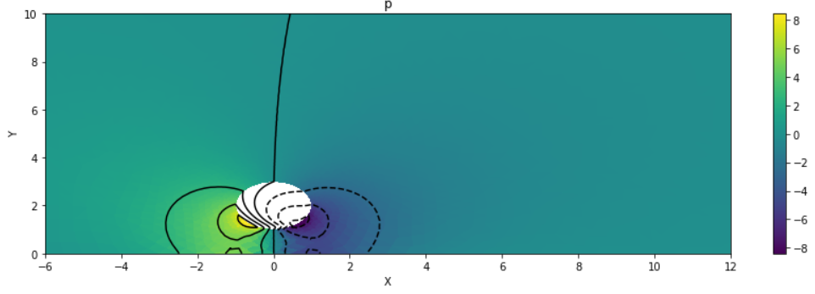

(2)L2 norm of errors

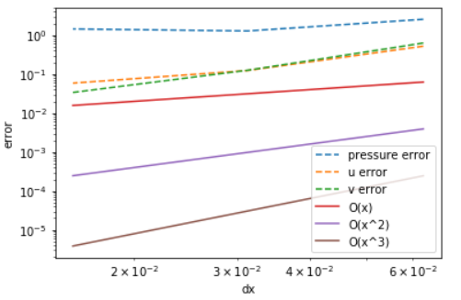

The norm of u v error is 2nd order convergence rate.

The norm of p error is 1st order convergence rate.

(3) pressure on two cross sections, x=[-6,12],y=0.5 and x=[-6,12],y=1.

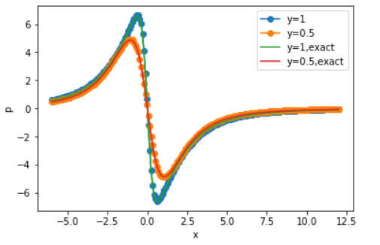

**Part 2(c)**

(1) solution fields (u, v and p) for the most fined mesh.

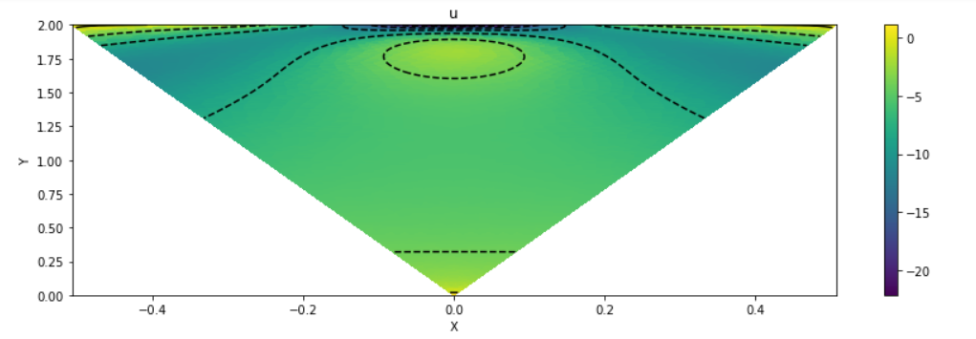

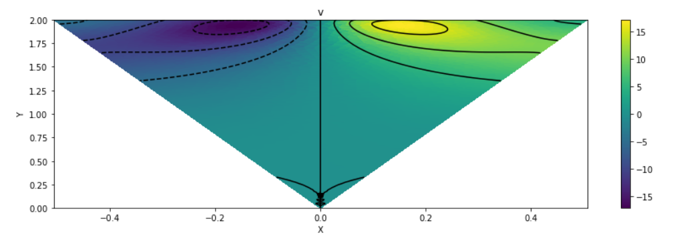

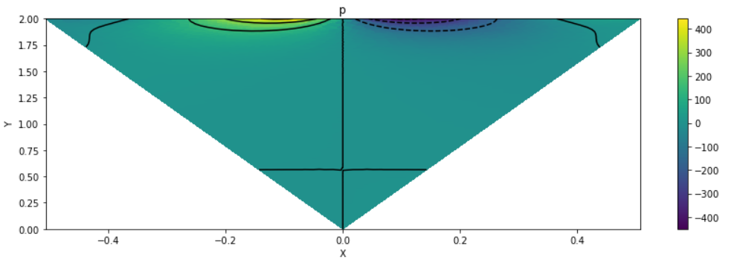

(2) pressure table

